## Email Analysis Report

**Introduction**

Email forensic analysis is a specialized branch of digital forensics dedicated to the investigation of email data. This process is essential for a variety of critical purposes, including legal proceedings, cybersecurity incident response, and internal organizational investigations. The core objective is to conduct a thorough and systematic examination of email communications to establish key facts, such as the origin of a message, the identities of the sender and recipient, the precise date and time of transmission, and the complete content of the correspondence.

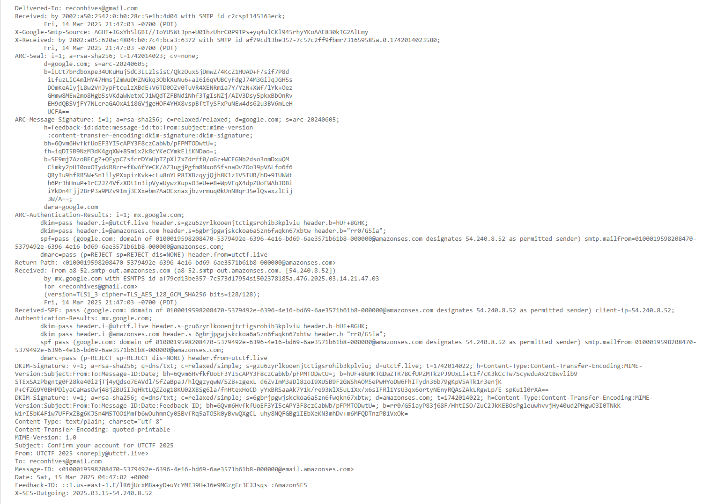

* **Email Header Analysis:**
  + Email headers contain crucial metadata that provides a detailed record of an email's journey. This information includes the sender's IP address, the various servers involved in transmitting the email, and precise timestamps.
  + By carefully analyzing these headers, investigators can determine whether an email is genuine or if it has been subjected to tampering or spoofing.
  + **Detailed Steps:**
    1. **Header Retrieval:** The process of obtaining email headers varies depending on the specific email client used.
    2. **Examination of "Received" Headers:** These headers are meticulously examined to trace the email's path, with the last "Received" header typically indicating the originating server.
    3. **Sender IP Address Identification:** The sender's mail server IP address, found within the "Received" headers, is identified to help determine the sender's location.
    4. **Inconsistency Detection:** Investigators look for any discrepancies in timestamps, server names, and IP addresses, as these may suggest alteration or spoofing.
    5. **Authentication Record Verification:** SPF, DKIM, and DMARC records are checked to validate the email's authenticity and identify any potential spoofing attempts.
* **Email Content Analysis:**
  + This involves a detailed review of the email's body, including all text, images, and attachments.
  + This analysis is crucial for identifying potential phishing attacks, the distribution of malware, or other malicious activities.
  + **Detailed Steps:**
    1. **Email Body Examination:** The email's text is scrutinized for any suspicious language, unusual requests for personal information, or other red flags.
    2. **Embedded Link Analysis:** The actual URLs of any links within the email are carefully examined, as they may differ from the displayed text and lead to malicious websites.
    3. **Image Analysis:** Images within the email are analyzed for any hidden code or steganographic elements.
    4. **Attachment Extraction and Analysis:** Any attachments are extracted for further investigation, including malware scanning and content analysis.
* **Metadata Extraction:**
  + Email metadata, which includes timestamps, sender and recipient details, and file properties, provides valuable context and helps establish a timeline of events.
  + **Detailed Steps:**
    1. **Timestamp Extraction:** The "Date" header is extracted to determine the precise time the email was sent.
    2. **Sender and Recipient Identification:** The "From," "To," "Cc," and "Bcc" headers are analyzed to identify all parties involved in the communication.
    3. **Email Client Information Analysis:** Headers such as "X-Mailer" or "User-Agent" are examined to identify the software used to send the email.
* **Attachment Analysis:**
  + Email attachments can pose significant security risks, as they may contain malware or other threats.
  + A thorough forensic analysis of attachments is essential and involves examining file headers, file content, and any embedded scripts.
  + **Detailed Steps:**
    1. **Attachment Extraction:** All attachments are extracted from the email for individual analysis.
    2. **File Header Verification:** File headers are examined to confirm the true file type, as malicious files may be disguised with deceptive extensions.
    3. **Malware Scanning:** Attachments are scanned using up-to-date antivirus software and specialized tools to detect any malicious code.
    4. **File Content Examination:** The content of the attachments is analyzed for any suspicious code, scripts, or hidden information.
    5. **File Metadata Analysis:** The file's metadata, such as creation date and author, is reviewed for any anomalies.
* **Email Server Analysis:**
  + Email server logs contain valuable information about email traffic, sender and recipient activity, and potential security breaches.
  + Examining these logs is crucial for understanding the flow of email communications and identifying any suspicious patterns.
  + **Detailed Steps:**
    1. **Server Log Acquisition:** The relevant email server logs are obtained.
    2. **Log Filtering:** Logs are filtered by specific criteria, such as date, time, sender, or recipient, to narrow the scope of the investigation.
    3. **Log Entry Analysis:** Log entries are examined to gather information about email transmission, delivery, and any errors that may have occurred.
    4. **Anomaly Detection:** Investigators look for any unusual activity, such as large volumes of emails, failed login attempts, or connections from unfamiliar sources.
* **Deleted Email Recovery:**
  + In certain investigations, recovering deleted emails is essential, particularly when individuals have attempted to conceal evidence.
  + This process involves retrieving email data from email servers or storage media.
  + **Detailed Steps:**
    1. **Storage Media Access:** The storage media that may contain deleted emails, such as hard drives or servers, is accessed.
    2. **Forensic Image Creation:** A forensic image of the storage media is created to preserve the data in its original condition and prevent any accidental alteration.
    3. **Data Recovery Tool Utilization:** Specialized data recovery tools are employed to scan the storage media for any recoverable deleted email data.
    4. **Deleted Email Recovery:** Any deleted emails that are found are recovered.
    5. **Recovered Email Analysis:** The recovered emails are then analyzed using the same techniques applied to regular emails to glean any relevant information.

**Tools Used in Email Analysis**

A range of specialized tools are employed in email forensic analysis to facilitate the efficient and accurate examination of email data. These include:

* Specialized email analysis software
* Network forensic tools
* Data recovery tools
* Visualization tools

**Challenges in Email Forensic Analysis**

Despite its importance, email analysis presents several challenges:

* The sheer volume of email data can be substantial, making analysis a time-consuming and resource-intensive task.
* Email data may be dispersed across various locations, including email servers, local computers, and cloud storage, complicating the collection and analysis process.
* Individuals may employ anti-forensic techniques to hide or delete email data, necessitating the use of advanced forensic methods.
* Encrypted emails pose a challenge, often requiring decryption keys or specialized tools for analysis.

**Conclusion**

Email analysis is a critical discipline that plays a vital role in uncovering digital evidence across a wide spectrum of investigations. By employing specialized techniques and tools, forensic investigators can effectively analyze email data to establish facts, identify wrongdoing, and support legal and organizational objectives.